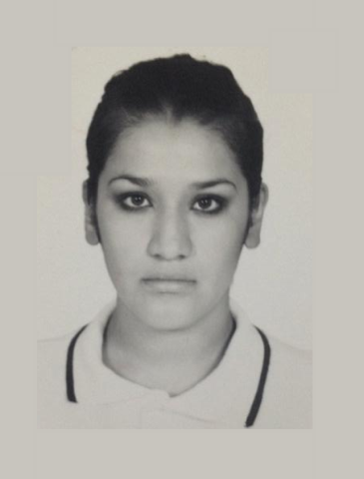**Personal Information**

**Name:** Joanna Elizabeth Guerrero Campos   
**date of birth**: may- 08-1990  
**Marital Status**: single   
**email:** [Joanna.guerrero.campos@gmail.com](mailto:Joanna.guerrero.campos@gmail.com)  
**telephone number:** 4171151593  
**Address:** #15 Jacarandas street

**School background**

High school: Miguel Hidalgo y Costilla /CBTis 147  
from: 2005-2009.

University: Universidad Tecnológica de León  
TUS   
Carrer: Informatics technology Multimedia Area

I have a web site, edition video and tecnition soport

**Factual studies.**

University: Universidad Tecnológica de León  
Engineering

Carrer: Informatics technology.

**Work experience**

2011-2012: I have worked in financial Finamigo as a savings advisor.

2012-2014: I have worked in cyber coffee as a manager.

2014: I have worked in IEEG as a data capturist.

2016-2018: I’m working in Stationery

2017: I have the experience of having made a multimedia guide for “Accident Prevention” of the institution Aurora Jimenez Alderete

Actually: I’m work in Fragua as a singer.

**Curse:**

Entrepreneurship

**Skills**

**I manage**: office programs, multimedia edition, web site in wordpress.

**Qualities**

Responsible, honesty, solidary, teamwork

**Referencies**

Fernando Abraham Aguado Juárez

Financial director

Tel. 4171026418  
  
Tania Gabriela Rufino Bazaldua

Administration licensed tourism companies

Tel. 4171773440